Technical Description: AC Adapter

Osvaldo Tapia
Hostos Community College
Technical Writing ENG 202
Professor Pamela Stemberg
March 7, 2023
The AC adapter is an object that is used for many components in our devices. This ranges from

laptops, cameras, speakers and many more. The history goes back to the year 1928 when Philip

F. Labre patented a design for a socket and plug that used pins. This is the design that we have

used for adapters now. Although this was not the first attempt to try this as previous designs

were also created by Harvey Hubbell who patented three designs that also use pins to use on

lamps In 1969 a US company designed a power supply that looks like the power strips we use today. The inventor was Robert Khan and he worked for the company Fedtro

The AC adapter has evolved and it is a design that has hundreds of different variations. It has

different voltage current capacity. The plugs can be same yet they have different voltage

current capacities. The AC adapter being explained here is for the simple design that we all

have in our houses. The one that is laying down at the bottom of you’re closet. We must have

more than a couple laying down. A simple AC adapter consist of a transformer, rectifier and

electronic filter.

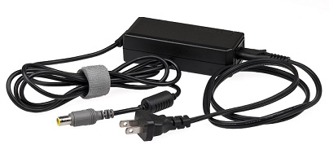
This is the common AC adapter that is used to charge a laptop. It is explained in this form, the

electricity passes through a transformer which in return lowers the voltage to the intended

voltage resistance of the adapter. The rectifier turns the AC current into DC current. Then the

filter is used to make the waves turn into DC current. The most common AC adapters can

receive from 90- 250 volts of AC. Having these clunky objects have their advantages as well.

Some include safety, this is because manufacturers don’t have to worry about hazards from

having the power supply inside the equipment. It also removes the heat from the equipment

away as the power supply is built outside the equipment the heat is away from the equipment.

This can lead to malfunction of the equipment.

Reference:

https://en.wikipedia.org/wiki/AC_adapter

Ac Adapters. Poptronics. 2002;3(7):51. Accessed March 8, 2023. https://search-ebscohost-com.hostos.ezproxy.cuny.edu/login.aspx?direct=true&db=bth&AN=6767136&site=ehost-live

https://www.vice.com/en/article/mg7xx8/the-story-of-the-ac-adapter-thomas-edisons-revenge-on-the-power-grid

https://energyeducation.ca/encyclopedia/AC_adapter#:~:text=A%20simple%20AC%20adapter%20consists,for%20the%20device%20being%20powered.

