Battery Charger Business Proposal
Hostos Electrical Engineering
500 Grand Concourse
Professor Pamela Stemberg

By
Osvaldo Tapia, Justin Ramirez, Felix De Los Santos
I am excited to present our business proposal for developing safer batteries for electric bikes. As electric bikes continue to grow in popularity, there is a pressing need for more reliable and safer battery technology. During 2022 it is reported that batteries caused 216 fires that led to 147 injuries and 6 deaths. As of Feb. 27, there have been 30 fires, 40 injuries and 2 deaths. This has all been data from New York. Not all batteries are made by manufacturers that have designed safety specs. Due to this wear and tear from the use causes batteries to damage and increase the risk of a fire. We believe that our proposed solution will address this need and provide an efficient and cost-effective alternative for electric bike users.

Market summary:
The electric bike market has been rapidly growing in recent years, with an estimated 130 million electric bikes sold globally in 2020. According to market research firm Allied Market Research, the global electric bike market is expected to reach $23.8 billion by 2025, growing at a CAGR of 7.5% from 2018 to 2025.

Despite the growth potential of the electric bike market, there are several challenges that need to be addressed, including the need for safer and more reliable battery technology. Our proposed technology offers a solution to these challenges and provides a competitive advantage for electric bike manufacturers and distributors.
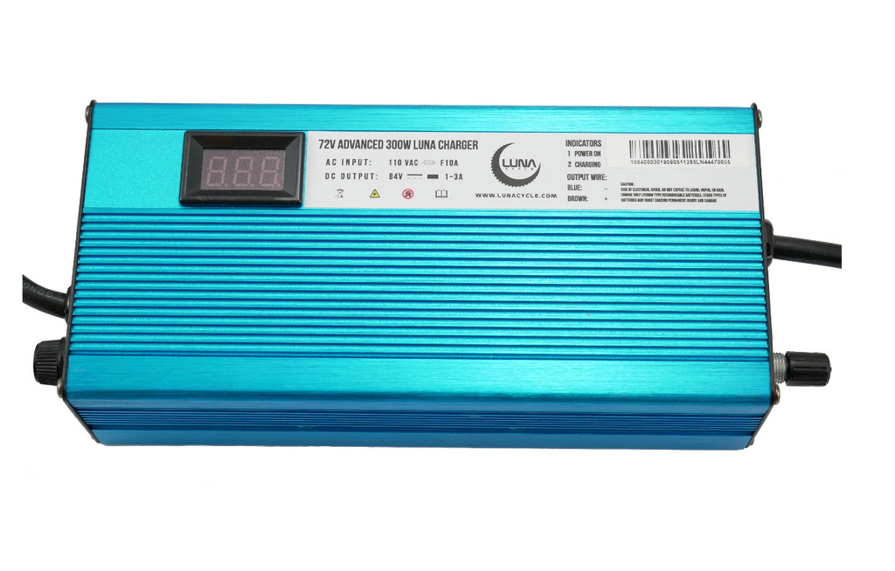
This model is a 72V charger. It is designed for lithium ion battery packs. We ca adjust the current to charge fast or slow from 1A to 3A.cSmart charger keeps your pack safe and maximizes its life span for better results in the performance of the battery. This pack automatically shuts down when pack is full. Voltage display lets you monitor your charge as you charge. High quality fans runs quiet and are reliable to keep the charger cool and safe.
Anodized Sea Blue aluminum case for a visual and more pleasant display. This model is
2.5 pounds and is light weight. The dimensions of this model are 7.25 x 3.5 x 2 (dimensions in inches). This model charges the battery to 84V.
Intellectual Property: We have already filed patents for our charging technology, providing us with a competitive advantage and protecting our innovation in the market. We are open to licensing our technology to interested manufacturers, facilitating widespread adoption across the industry. Patent #US66043221
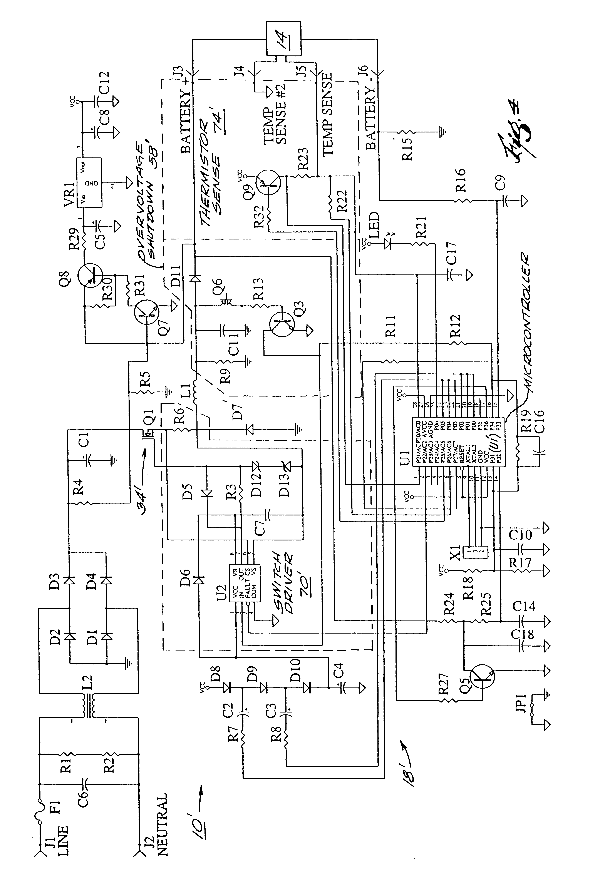Our company has conducted extensive research into the current state of electric bikes and has identified several key areas for improvement. Our proposed battery technology offers the following benefits:

Enhanced Safety: Our technology incorporates advanced safety features that reduce the risk of overheating, short circuits, and other common battery-related issues. This ensures that electric bike users are safe while their battery charges.
Longer Lifespan: Our power brick adapter are designed to have a longer lifespan than traditional ac-adapters. This means that they will need to be replaced less frequently, reducing costs for users and reducing environmental impact.
Quick Charging: Our battery technology includes fast-charging capabilities, allowing users to quickly recharge their electric bike batteries and get back on the road.
Environmentally Friendly: Our power brick technology is designed to be more environmentally friendly than traditional ac adapters. This reduces the environmental impact of electric bike use and supports sustainable transportation.
We plan to bring our technology to market by partnering with electric bike manufacturers and distributors. Our target market will initially be the United States, where electric bike use is growing rapidly. And then explore more markets either overseas or in growing economies in Africa. We propose collaborating with electric bike manufacturers to integrate our chargers into their product lines. By offering a strategic partnership, we aim to provide manufacturers with a charger that will ensure the safety of their electric bikes.

To achieve this goal, we will need to raise capital to fund the development and testing of our battery technology. We plan to do this through a combination of venture capital funding, government grants, and crowdfunding.

Our team has extensive experience in the field of battery technology and is committed to bringing safer and more reliable power bricks to the market. We believe that our proposed solution will provide a competitive advantage for electric bike manufacturers and distributors and will meet the growing demand for safer and more efficient technology.
Conclusion:
Our business proposal presents an exciting opportunity to transform the electric bike industry by addressing the limitations of existing batteries. By partnering with manufacturers and offering advanced battery technology, we can unlock the full potential of electric bikes, providing consumers with enhanced performance, longer range, and improved sustainability.

Thank you for considering our proposal. We look forward to the opportunity to work with you to bring our technology to market and contribute to a safer and more sustainable future.

Reference:
72V 300W ebike advanced Luna Charger. Luna Cycle. (n.d.). https://lunacycle.com/batteries/chargers/72v-300w-ebike-advanced-luna-charger/
Cohen, J. (2023, March 6). E-bikes are convenient. they can also cause fatal fires. The New York Times. https://www.nytimes.com/2023/03/06/realestate/e-bikes-fires-danger.html#:~:text=Delivery%20workers%20are%20increasingly%20reliant,147%20injuries%20and%20six%20deaths.
Electric Bike market size, share, Analysis - E-Bike Trends Report. Allied Market Research. (n.d.). https://www.alliedmarketresearch.com/electric-bikes-market

